Implementing Playwright with Typescript in the browser extension

Ask-
This project does not support playwright with typescript. Analyse the folders, files and functions and check what files needs to be updated so that we can implement playwright with typescript.

Ask-
Act as a Senior Architect and go through th files and folder and understand the project. This will help in further enhancements and modification if needed.

Plan: Project is having a implementation for Selenium with Java programming language. Using Java as a language and Selenium as browser engine from the settings we are able to generate Selenium code with java. Similarly we need to have a implementation for Playwright with Typescript. So that Playwright Typescript test codes can be generated using Playwright from browser engine and Typescript from language. This implementation should not impact existing selenium with java. Analyse the files and functions that would be impacted by this new implementation. I need to review and approve. Then proceed with the implementation in Agent mode.

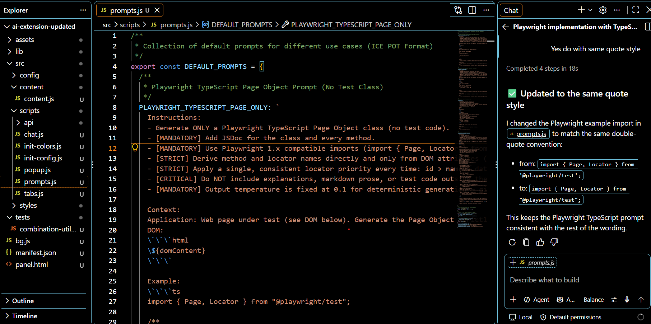

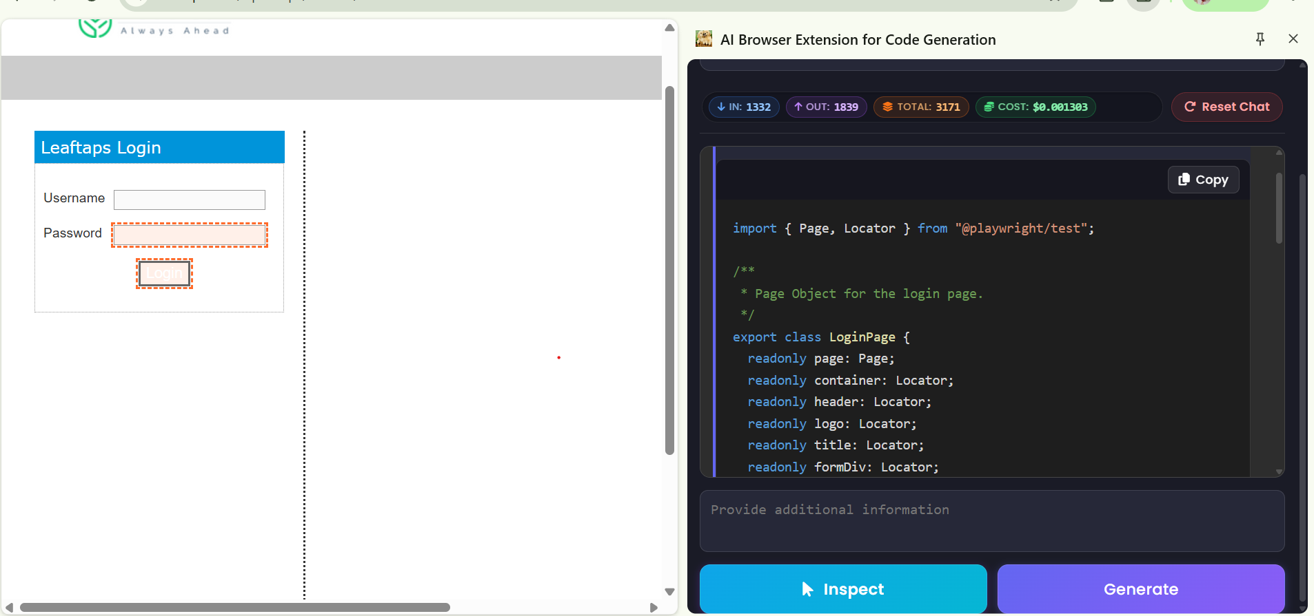

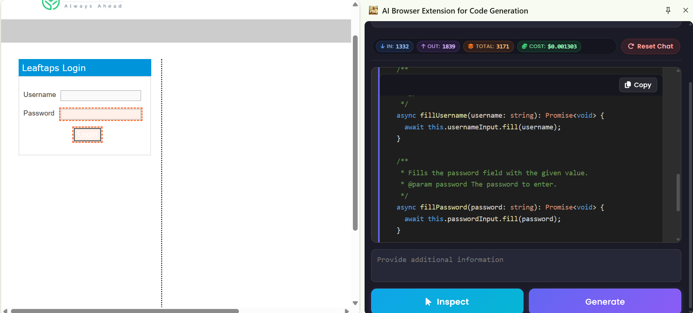

ASK-
At present in this Ai-extension under settings , we do not have javascript in the supported language.Go through the files and functions and tell us what all gets affected if we want to add Javascript in the supported language
Lets implement this change of adding javascript as one of the supported language inside settings

